**Game Design**

**Core Game Play**

Our game will be inspired by Geometry Wars and so it is a Shoot ‘Em Up game. Having the player fight waves of various enemies. The enemies will gain various abilities over time.

**Game Flow**

Close game

Quite

Title Screen

Display controls

Controls

Play

Easy

Difficulty

Medium

Hard

Through the difficulty that the player chooses, the enemies will spawn at different rates at the beginning of the game. The player will then survive for as many rounds as possible, gaining points for each time they destroy an enemy. Once the player reaches a certain amount of score then the next wave of enemies will begin.

**Characters**

S.T.E.V.E (Super Terrestrial Evolutionary Vapor Enigma) is the character the user will be playing as. He is an ever enhancing space ship, which was created to defend Earth from the alien ships. The starting enemies are the lowest and the least dangerous, after time, the enemies will slowly advance to the highest and most dangerous enemies.

**Game Play Elements**

The player will be able to acquire extra lives, they will also be able to acquire weapon upgrades to allow them to have a higher fire rate/more bullets.

**Game Physics and Statistics**

**Artificial Intelligence**

The lower difficulty AI will try and run into the player, following them around the map until so. The higher difficulty AI will try and shoot the player, which damages them. Once the player is run into/shot then they will lose a life point and will be slowed for a little while.

**Multiplayer**

There will be a head-to-head game mode where two players (player 1 and player 2) will fight each other, and whoever shoots the other one down first, wins. There will be another game mode that will be co-operative, where, player 1 and player 2 will fight oncoming waves of enemies and will try to survive.

**User Interface & Flow Chart**

Close game

Quite

Title Screen

Display controls

Controls

Play

Multiplayer

Single-player

Hard

Medium

Easy

1 v 1

Co-Operative

Difficulty

**Functional Requirements**

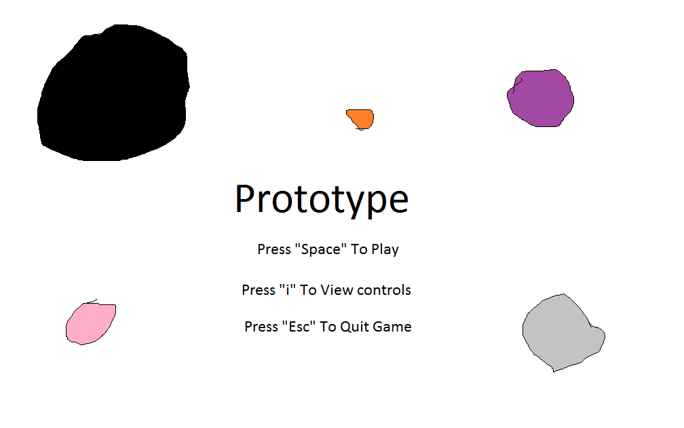**Mock-ups**

**GUI Objects**

**Art and Video**

**Overall Goals**

Our overall goal is to create a functioning game with no bugs, have the player be able to move freely and have the enemies spawning in a certain radius around the player. The enemies will hopefully spawn over a certain amount of points that the player earns.

**2D Art and Animation**

* **GUI**
  + The game will have a main menu and a pause menu for mid-game.
* **Marketing and Packaging**